Basic Principles of Epidemiology: 573a

Homework 1: Patterns / Causation

Purpose: to help you begin to think about patterns of disease as an epidemiologist does.

Lectures Modules referenced: Causation (3 – 7), Patterns (8)

  - Take a look at the Course Grading table posted on D2L in the course syllabus (in the section labeled Course Requirements / Student Evaluation).

- How many points in the course are given simply for submitting your completed work on time?
5 pts

- How many points are from assignments that are graded?
900

- If you turn in every assignment on time how many more points do you need to earn to get

  - an A in the class? 800

  - a B? 700

- What must your average grade be on the graded assignments to earn:

  - an A? 80%, I admit I am a little confused by this question, i.e. how are we calculating the average? The average of the percentages would have to be weighted by the associated points for this to hold.

  - a B? 70%

  - The following figures illustrate ways in which the risk of disease might vary with respect to age. Describe the relationship of risk and age for each graph and then try to explain why these relationships might show these patterns. Consider aspects of agent, host, and environment. The x axis may not necessarily include the entire lifespan, but could be days or months for some of the graphs.

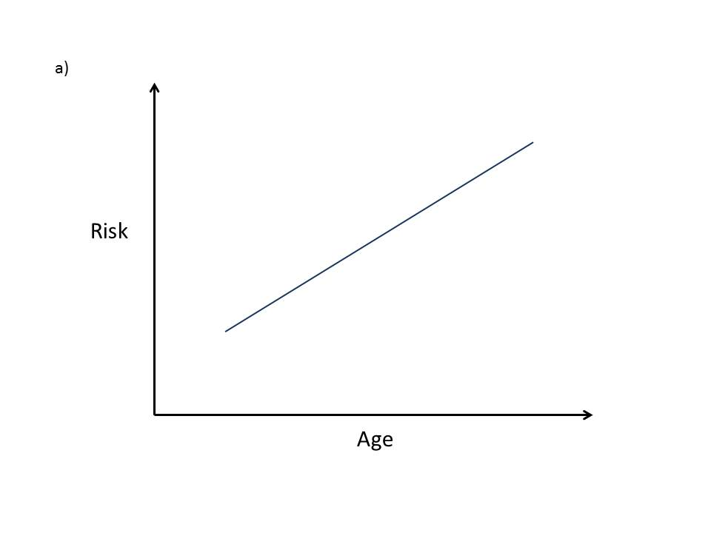
Here risk appears to increase linearly with age. This might be because age is a surrogate for cumulative exposure to something, e.g. UV sunlight. It could also be related to some stochastic biologic process which increases in variance over time, such as spermatogenesis.
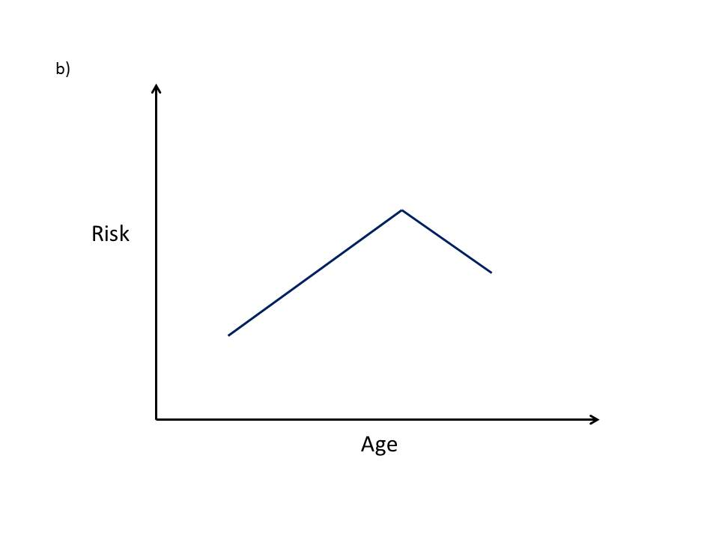
Here there appears to be a structural break where the slope of the relationship between age and risk changes sign. This could be due to some developmental milestone. For example, the risk of car accidents by males may increase from age 16 to 25 and then begin to decline as they get old and boring.

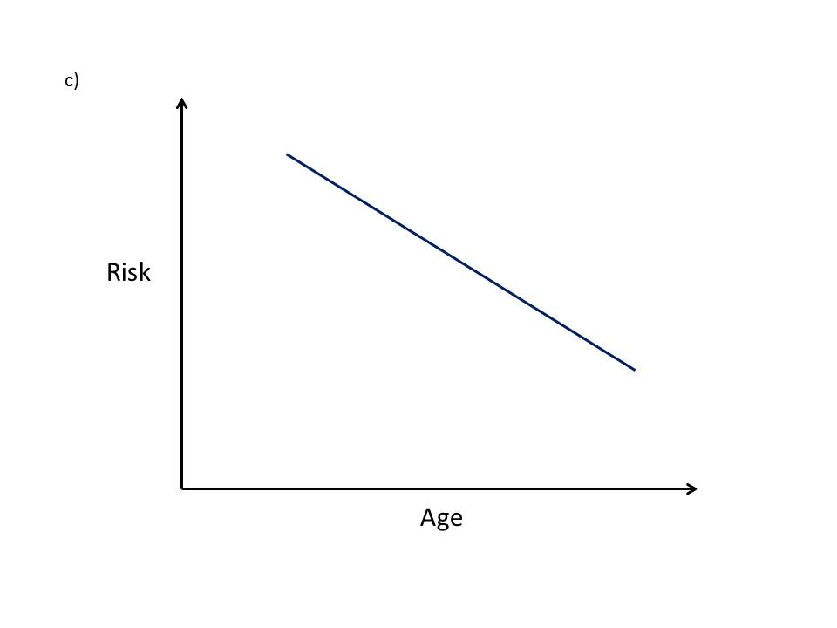
Here we have a linearly decreasing relationship between age and risk. We might see this in the risk of ear infections among children age 2 to 6.

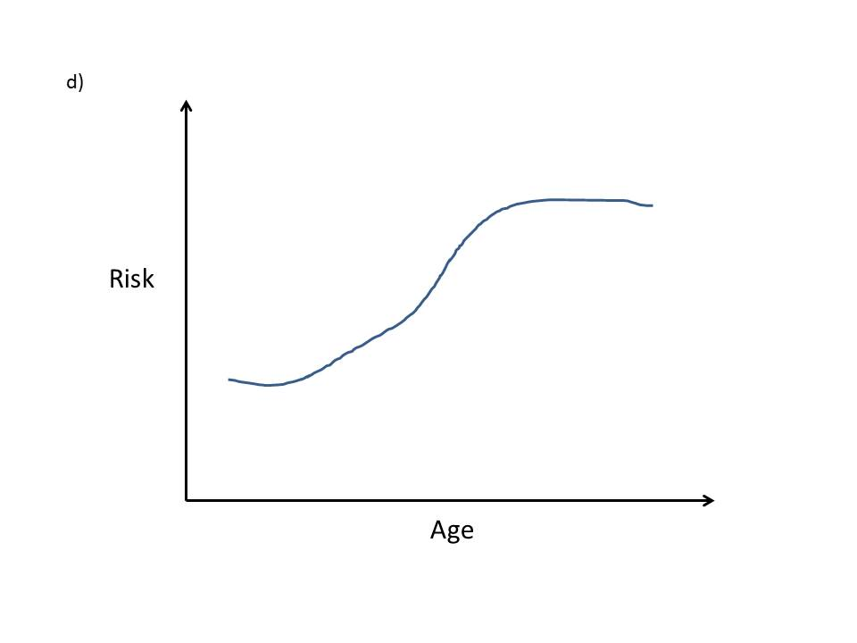
Here we see a sigmoidal relationship between age and risk. Risk is initially low and then increases dramatically where it then remains at an elevated state. If we are considering a short time period, say from the time someone wakes until they arrive at work, this could be the risk of being scalded by hot coffee. I would imagine the risk would decrease has the day progresses into afternoon so the plot would have to be truncated at a time when one is still in the presence of hot coffee. Initially the risk is low because the subject is in bed.
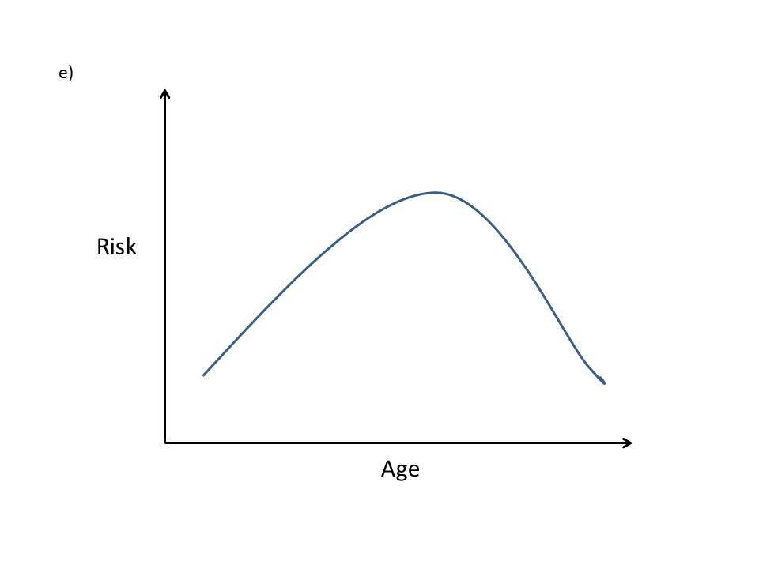
Here we see a quadratic association between risk and age. This could easily be due to some diurnal risk factor associated with being out of the house such as the risk of being caught in the rain.

  - Name at least three concepts that are useful in assessing causality.
Temporal relationship
Dose-Reponse
Experiment

  - Considering the evidence presented in the Mini Quiz for this week, do you believe the association between alcohol and breast cancer is causal? Why or why not?
There does seem to be some compelling evidence that alcohol consumption is causative for breast cancer. However, I would like to see some sort of dose-response evidence since the mechanism of the biological plausibility would support such a relationship.

  - During an outbreak of a severe neurological disease of unknown cause, the families of the patients suggest that the cause is adulterated cooking oil of a particular brand. Considering the criteria for causality, what would you try to demonstrate first? What type of study would be suitable? At what stage would you intervene if the accumulating evidence showed that the oil might be the cause?

I would first conduct a case-control study to determine if the strength of association warrants further investigation. If the odds ratio were significantly greater than 1 I would feel intervention was necessary.

  - Most Western countries have shown sharp declines in infant mortality since 1900. In the United States, infant mortality has declined for both whites and blacks, but differences between the races have persisted over time. Variations over time and between racial groups can give information about several causes of infant mortality. Infant mortality rates in the United States (deaths under 1 year of age per 1000 live births) are listed below by year and race.[See next page for Table]

Table 1. Infant mortality (deaths under 1 year per 1,000 live births)

YEAR | WHITE | BLACK
1915-1919 | 92.8 | 150.4
1920-1924 | 73.3 | 117.3
1930-1934 | 55.2 | 90.5
1940 | 43.2 | 72.9
1950 | 26.8 | 43.9
1960 | 22.9 | 44.3
1970 | 17.8 | 32.6
1980 | 11.0 | 21.4
1987 | 8.6 | 17.9

- What are some arguments that the time trends are real, not artifacts?
The trend is consistent and the same for both races. Also, the likelihood of recording an infant death has probably increased over time, which would produce a trend in the opposite direction.

- What effect would improved birth registration have on these data?
Improved birth registration would likely decrease the mortality rate if the death registration remained the same.

- What effect would improved death registration have on these data?
Improved death registration would increase the observed rate of infant mortality if the birth registration was not also concomitantly improved.

- What might explain the decline in infant mortality between 1915 and 1960?
Improved access to health care and nutrition.

- What might explain the decline in infant mortality between 1960 and 1987?
Improvements to the built environment which make the world safer for infants.

- What are three hypotheses that might explain the differences in infant mortality between whites and blacks?
There is still a gap in socio-economic status between whites and blacks. Therefore, it is likely that blacks still do not have equivalent access to healthcare, neo-natal education, nutrition, and safety products as their white peers.

method-dependent result: something that appears to exist because of the way a thing, data, or the like is examined, for example, a form of behavior that is produced by a behavioral test http://encarta.msn.com/dictionary_/artifact.html

